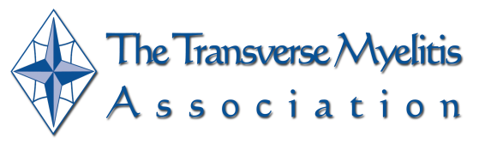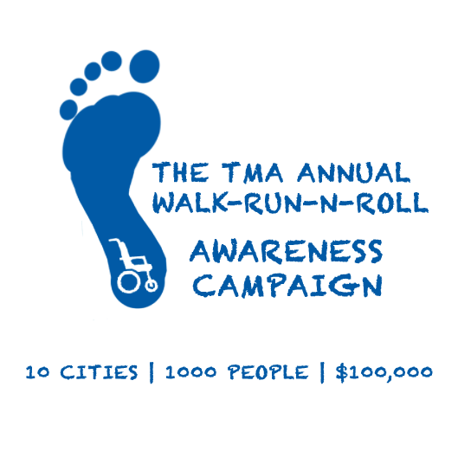

About The Transverse Myelitis Association (TMA)

The Transverse Myelitis Association (TMA) is a not-for-profit dedicated to the support of children, adolescents, and adults with a spectrum of rare neuro-immunologic disorders including: Acute Disseminated Encephalomyelitis (ADEM), Neuromyelitis Optica (NMO), Optic Neuritis (ON) and Transverse Myelitis (TM). Very little is understood about the disease mechanisms for these disorders. It is believed that a person who develops one of these rare neuro-immunologic disorders likely has a genetic predisposition to auto-immunity, and that there are environmental factors that interact with these genetics to trigger the disease. No one yet understands why some people have a good recovery from an attack, while others have no recovery at all.

Founded in 1994 by family members and persons with these diagnoses, the TMA was incorporated on November 25, 1996 in the state of Washington and we became a 501(c)(3) organization on December 9, 1996.

Membership of the TMA includes individuals with these rare disorders, their family members and caregivers, and the medical professionals who treat individuals with these disorders. The TMA currently has approximately 9,000 members from more than 80 different countries and has a large number of support groups across the United States and around the world. There are no membership fees.

The goals of the TMA are to advance a comprehensive network of medical professionals dedicated to the care of patients, to support research to further the understanding of the causes of TM, ADEM, ON and NMO, and to develop new acute and regenerative therapies. The TMA also offers a support network between persons with these disorders through local support groups located throughout the world. The James T. Lubin Fellowship was established to attract new clinicians and researchers into the rare neuro-immunologic disorder discipline. In addition to publishing newsletters to update the community on current research and various community outreach events and opportunities, the TMA supports and conduct various educational events involving clinicians, scientists, and individuals affected by these disorders for the exchange of information regarding research and treatment strategies, including annual family camps for children with these disorders and their family members.

TMA Walk-Run-N-Roll Nationwide Awareness Campaign

The TMA is launching a Walk-Run-N-Roll campaign to increase awareness and raise funds for research and programs that the TMA offers, such as our James T. Lubin Fellowship and our education programs. The goal is to launch the campaign in 10 different cities across the nation starting in April 2013. In addition to events, as part of the campaign we will also be sharing stories from our community to increase awareness about these rare neuro-immunologic disorders through various social media strategies, publications and podcasts.

My Story

**[TO CUSTOMIZE THIS LETTER INCLUDE YOUR PERSONAL STORY HERE]**

To learn more and register for one of the cities, please visit <http://myelitis.org/walk>. You can register and join us. To support our cause please go to <http://myelitis.org/donate>. To learn more about the TMA, please visit us at [www.myelitis.org](http://www.myelitis.org)

The Transverse Myelitis Association is a registered nonprofit organization in the States of Ohio and Washington and is recognized by the U.S. Internal Revenue Service as a 501(c)(3) organization. Donations are tax deductible to the extent provided by U.S. law. Our Tax ID number (EIN) is 91-1780467.