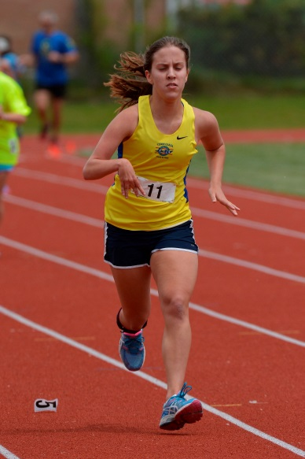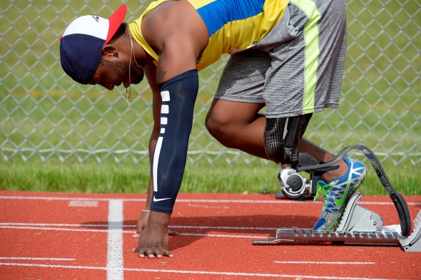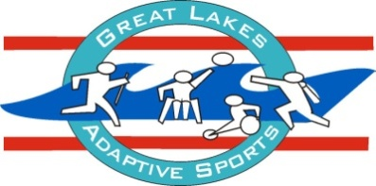

Great Lakes

Adaptive Sports Association

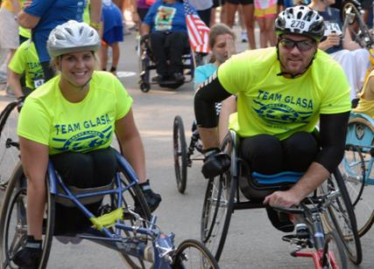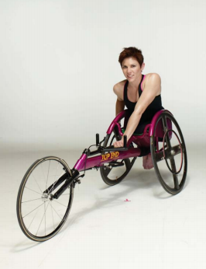**Track Clinic for Youth, Teens, & Adults**

**For the First Time to Elite Competitor**

**Sunday, March 1, 2015**

**Vernon Hills High School – Fieldhouse**

145 Lakeview Parkway, Vernon Hills, IL 60061

**Ambulatory Runners Wheelchair Racers**

Registration 8:30-9:00am Registration 12:00-12:30pm

Clinic 9:00-11:30am Clinic 12:30-3:00pm

**Special Guests & Presenters**

**Amanda McGrory** **Amie Stanton Day**

2012 Track Paralympian 2000 Track Paralympian

Winner Paris Marathon **Dave Bogenschutz** GLASA Track Coach

2014 & 2015 Coach for Ambulatory Athletes at

International Wheelchair & Amputee Sport World Junior Games

GLASA High Performance Track Coach

**Dave Michael Emily Petrusky**

CrossFit Trainer & Amputee Athlete Nutrition & Wellness Advocate

Attendees will be grouped by age and experience. The clinic will include but is not limited to:

>Practice & Competition Calendar Review >School & college Sports Participation

>Video Taping & Gait Analysis >Video Taping & Stroke Analysis

>Roller Workouts >Ambulatory Workouts

>Sports Nutrition >Cross Training

>Pushing & Stroke Technique

**Paralympians will share their training and techniques to advance to the next level!**

*New wheelchair track athletes must register for a seating and positioning time slot*

**Please fax this registration form to 847-283-0973 or e-mail to** [nverneuille@glasa.org](mailto:nverneuille@glasa.org). **Feel free to contact Cindy Housner** [chousner@glasa.org](mailto:chousner@glasa.org)

**or Nicole Verneuille if you have questions or need additional information.**

**2015 GLASA Track Clinic**

**Name:__________________________________________________________**

**Parents Name** (if under 18):___________________________________________________

**Date of Birth: _____ Address: _____________________ City: _____________**

**State:_______ Zip: _____________**

**Email: ________________________ Preferred Phone: __________________**

**School/College**(if applicable):_____________________________________________

**Injured Veteran:** **___** Yes ___No

**First Time Athlete:** ___Yes ___No

**Ambulatory Athlete:** ___Yes ___No

Disability: ___Amputee ___CP ___VI ___Other:___________________

**Wheelchair Athlete:** ___Yes ___No

Disability: ___SCI ___CP ___Spina Bifida ___Transverse Myelitis

___Other:______________________

___I own my own track chair, ___Helmet, ___Gloves and will be bringing them with me.

___I will need to use a GLASA track chair

Height: ­­­________ Weight: _______ Width Hip to Hip: ________

*New Wheelchair Track Athletes should sign-up for a time slot to be seated:

___1:00pm

___1:30pm

___2:00pm

___2:30pm

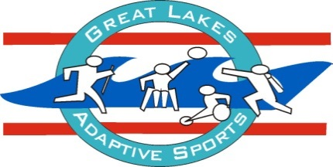

**Waiver Form - GLASA**

***PARTICIPATION WILL BE DENIED IF THE SIGNATURE OF THE ADULT PARTICIPATING OR PARENT/GUARDIAN OR PARTICIPANT AS WELL AS DATE ARE NOT ON THIS WAIVER.***

**NOTE: THIS FORM MUST BE READ AND SIGNED BEFORE THE PARTICIPANT IS ALLOWED TO TAKE PART IN ANY TRAINING, COMPETITION, MEETING OR TESTING SESSIONS.   
BY SIGNING THIS FORM, THE PARTICIPANT AFFIRMS HAVING READ THE WAIVER.**

**PARTICIPANT’S NAME: ____________________________________________________ DATE OF BIRTH: _____/____/___**

SPONSORING ORGANIZATIONS: Wheelchair and Ambulatory Sports, USA and Great Lakes Adaptive Sports Association

IN CONSIDERATION of being allowed to participate in any way in the sports and activities of Wheelchair and Ambulatory Sports, USA and Great Lakes Adaptive Sports Association my involvement under the auspices of Wheelchair and Ambulatory Sports, USA and Great Lakes Adaptive Sports Association, this sponsoring organization, I acknowledge, appreciate and agree that:

1. The risk of injury from the activities involved in this program is significant, including the potential for permanent paralysis, dismemberment and death and while particular rules, equipment and personal discipline may reduce the risk, the risk of serious injury does exist; as well as loss of or damage to property.

I KNOWINGLY AND FREELY ASSUME ALL SUCH RISKS; both known and unknown, EVEN IF ARISING FROM THE

NEGLIGENCE OF THE RELEASES or others, and assume full responsibility for my participation; and, I, willingly agree to comply with the stated customary terms and conditions for participation. If however, I observe any unusual or unnecessary hazard during my presence or participation, I will bring such to the attention of the nearest official immediately; and, FOR MY SELF, AND ON BEHALF OF MY HEIRS, ASSIGNS, PERSONAL REPRESENTATIVES AND NEXT OF KIN, HEREBY RELEASE, HOLD HARMLESS Wheelchair and Ambulatory Sports, USA and Great Lakes Adaptive Sports Association, THEIR OFFICERS, OFFICIALS, AGENTS, AND/OR EMPLOYEES (“Releases’), WITH RESPECT TO ANY AND ALL INJURY, PARALYSIS, DISMEMBERMENT, DISABILITY, DEATH, and/or LOSS or DAMAGE TO PERSON OR PROPERTY WHETHER CAUSED BY THE NEGLIGENCE OF THE RELEASES OR OTHERWISE, EXCEPT THAT WHICH IS THE RESULT OF GROSS NEGLIGENCE and/ or WANTON MISCONDUCT.

PUBLICITY STATEMENT: **I DO NOT**_____ grant permission for pictures taken of participant (taken by individuals; i.e. other participants, parents, etc.) and name of participant to be used by GLASA for the purpose of agency promotion and education.

EMERGENCY TREATMENT PERMISSION: I know that GLASA does not carry medical or accident insurance. My family’s own health insurance must assume responsibility in the event of injury. I understand that every precaution is taken to protect the safety of each individual. I agree to emergency treatment by a physician or hospital in the event I cannot be reached.

**I HAVE READ THIS RELEASES OF LIABILITY AND ASSUMPTION OF RISK AGREEMENT, FULLY UNDERSTAND ITS TERMS, UNDERSTAND THAT I HAVE GIVEN UP SUBSTANTIAL RIGHTS BY SIGNING IT, AND SIGN IT FREELY AND VOLUNTARILY WITHOUT ANY INDUCEMENT.**

____________________________________________ ___________________________________ **PARTICIPANT’S SIGNATURE DATE SIGNED**

**FOR PARTICIPANTS UNDER THE AGE OF 18 AT TIME OF REGISTRATION** This is to certify that I, as parent/guardian with legal responsibility for this participant, do consent and agree not only to his/her release but also to release and indemnify the Releases from any and all liabilities incident to my minor child’s involvement or participation in these programs for myself, my heirs, assigns and next of kin.

**__________________________________________ ____________________________ PARTICIPANT’S SIGNATURE DATE SIGNED**

**__________________________________________ _____________________________ PARENT/GUARDIAN’S SIGNATURE DATE SIGNED**

**EMERGENCY PHONE NUMBER:­ ­­­_______________________________**